https://jazz.net/_images/products/rational-quality-manager-52.png

Rational Quality Manager and Rational Test Lab Manager

**A collaborative ALM software quality delivery environment**

**IBM Rational Quality Manager** enables [Quality Assurance](http://en.wikipedia.org/wiki/Quality_Assurance) teams to track all aspects of the quality assurance effort. The central artifact in the tool is a dynamic test plan that contains all information related to the quality assurance effort, such as goals, schedules, milestones and exit criteria as well as links to associated test cases, requirements and development work items.

**IBM Rational Quality Manager** is a web 2.0 application which runs in a browser. Data is stored and managed on the Rational Quality Manager server.

IBM Rational Quality Manager provides a collaborative application lifecycle management (ALM) environment for test planning, construction, and execution. Rational Quality Manager helps meet the challenges of software testing with effective workflow control, tracking, and traceability features. The application also offers metrics analysis and reporting functions that quantify how project decisions impact and align with business objectives.

**Rational Quality Manager Key Artifacts**

**Requirements:**

Requirements are a key input to the quality assurance process. streamlined facility enables requirements management direction from the Quality Manager interface. Regardless of the source of requirements, Rational Quality manager can generate test cases from requirements, can associated test plans and test cases to requirements and will notify the user when a requirement associated to a test plan or test case has changed.

**Test Plan:**

The test plan is the central artifact in Rational Quality Manager and contains both static and dynamic information regarding the quality assurance effort. Some of the static information gathered includes Business Objectives, Test Objectives, Test Team, Entry and Exit Criteria. Some of the dynamic information contained in the test plan includes requirements and test cases.

### Test Cases

Test cases are the single most important element of the test plan. The test case defines the what, where, why and how of a test. Specifically, what is to be tested, on which platforms it is to be tested, the purpose of the test and how the test will be executed. In terms of execution, Rational Quality Manager has the native ability to author and execute manual test scripts as well as the ability to launch automated test scripts from Rational Functional Tester, Rational Performance Tester and Rational Service Tester. Various execution adapters are also available which enable execution of other tests from third party vendors.

### Test Lab Assets

Test lab management involves the tracking of test lab assets and their configurations, provisioning of test lab assets and scheduling of test lab assets. Rational Quality Manager provides a basic lab management capability as a standard feature and also offers additional functionality from Rational Test Lab Manager for additional lab management functionality, such as integrations to automated lab discovery and provisioning tools from IBM Tivoli.

### Defects

Defect reports are one of the key outputs of the quality assurance process. Like requirements management, Rational Quality Manager offers the ability to manage defects natively, within the Rational Quality Manager architecture or to establish links to external issue tracking solutions such as Rational ClearQuest and Rational Team Concert.

### Reports

Rational Quality Manager offers a series of packaged reports for reporting on all aspects of the quality assurance process. With the v2.0 release, Rational Quality Manager has begun integrating new advanced reporting functionality which enables users to create and modify additional reports.

### Dashboard

The Rational Quality Manager dashboard itself is not a key artifact, but the default interface which displays artifact information. The dashboard in Rational Quality Manager is fully customizable so that users can choose what content they would like to have on their desktops at all times. The dashboard can display information from Rational Quality Manager as well as from RSS feeds.

IBM Rational Test Lab Manager integrates fully with Rational Quality Manager and helps to improve the efficiency of the test lab and optimize how resources are requested and provided. You can also integrate Rational Quality Manager with Rational solutions in these areas: security, functional testing, performance testing, web services testing, and run-time analysis testing.

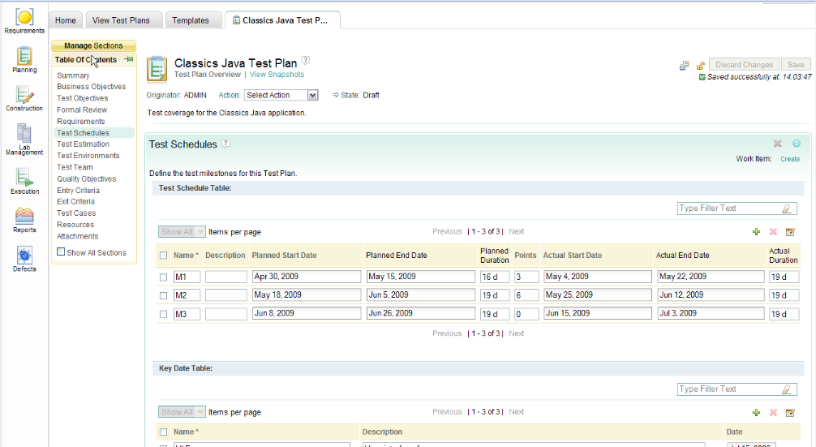

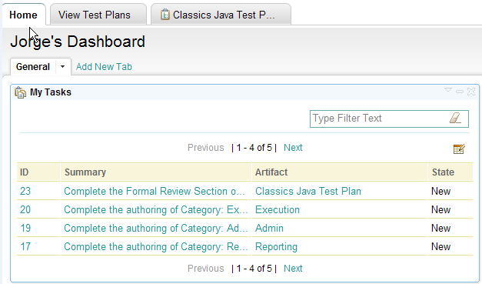

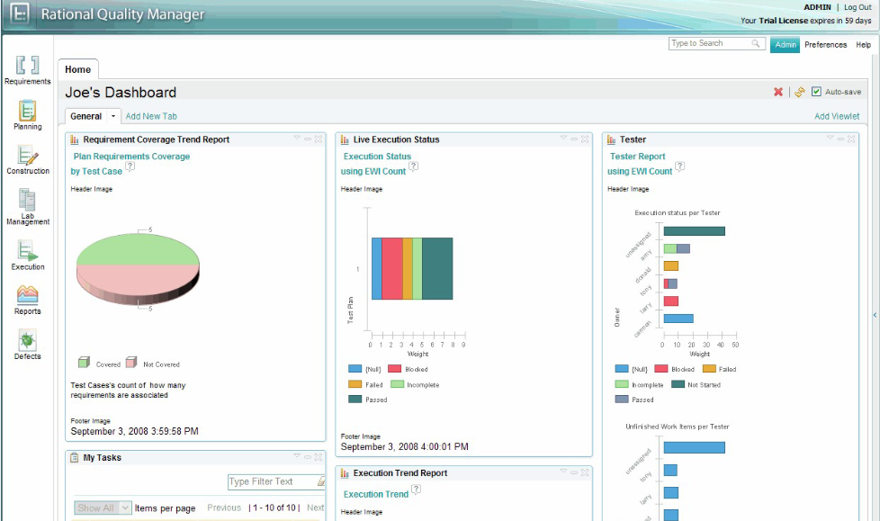

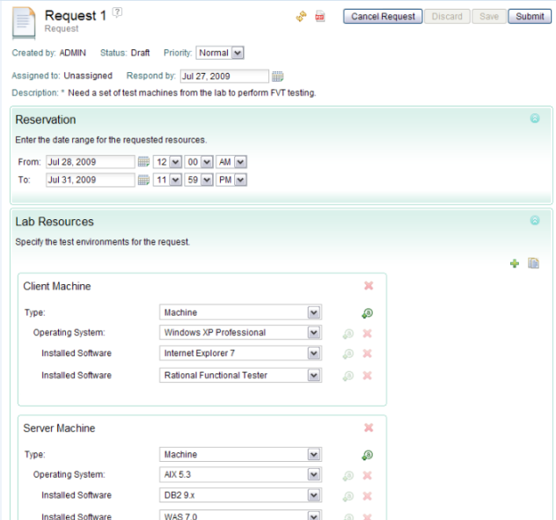

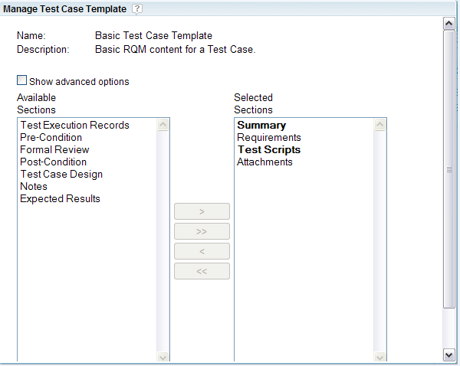

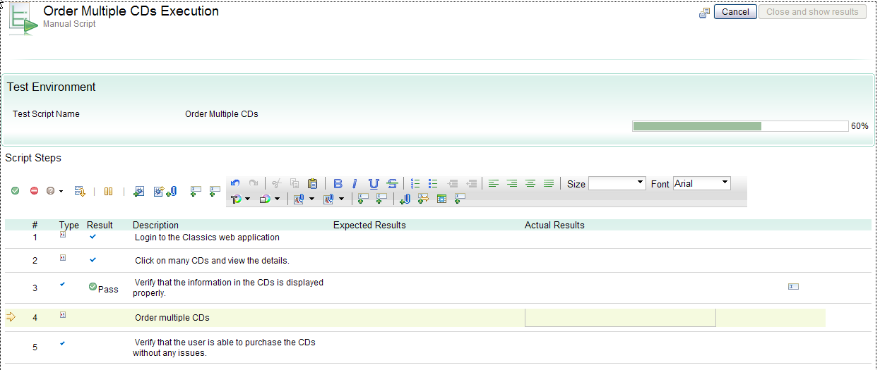

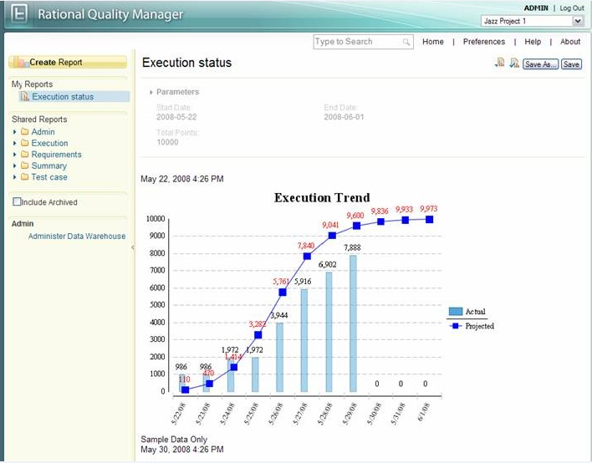

<http://en.wikipedia.org/wiki/IBM_Rational_Quality_Manager#Overview>

<http://download.boulder.ibm.com/ibmdl/pub/software/dw/demos/RRCReqpro/RRCReqProIntegDemo.html?S_TACT=105AGY50&S_CMP=DEMOS>